Nebyu_AI Lab: Pair Programming with AI - Part 2
Task 1: AI Implementation & Quality Submission Document | Artificial Intelligence in Software Engineering
Repository: https://github.com/nebyu11/Artificial-Intelligence-in-Software-Engineering
Task Directory: AI Lab Pair Programming with AI - Part 2
1. Full Structured Prompts Used
Prompt 1: Scope & Closures Audit Prompt
Act as a senior JavaScript engineer performing a code audit. Please analyze the addTask method in the following TaskQueue legacy code snippet:
class TaskQueue {
constructor(name) {
this.queueName = name;
this.tasks = [];
this.isProcessing = false;
}
addTask(taskFn, priority) {
if (!taskFn || typeof taskFn !== 'function') {
console.error('Task must be a function.');
return;
}
this.tasks.push({ taskFn, priority, timestamp: Date.now() });
if (this.tasks.length === 1) {
console.log(`Starting queue ${this.queueName}.`);
this._startProcessing();
}
function notify() {
if (priority > 9) {
console.warn(`High priority task added to ${name}.`);
}
}
notify();
}
}
Specifically:
1. Explain the scope of the nested notify() function and detail exactly what variables it closes over upon execution.
2. Identify any variables or parameters that are referenced inside notify() which create scope bugs or reference errors (such as attempting to reference name instead of this.queueName), and explain why.
3. Detail which variables should be properly block-scoped using let or const (rather than relying on outer function parameters or implicit globals) and why block-scoping is essential for predictable, bug-free execution in asynchronous or event-driven JavaScript environments.
Prompt 2: Single Responsibility Principle (SRP) Refactoring Prompt
Act as a software architect specializing in Object-Oriented Design and SOLID principles.
Analyze the addTask method of TaskQueue from a Single Responsibility Principle (SRP) perspective:
1. Identify all SRP violations currently present inside addTask (specifically pointing out state checking, console logging, automatic queue processing/scheduling, and priority notification side effects).
2. Refactor the TaskQueue class by extracting the logging, notification, and process-scheduling side-effects out of addTask into a dedicated logger/notifier component (or separate helper class TaskQueueLogger).
3. Ensure that addTask becomes purely responsible for validating and appending the task object to the internal this.tasks array, while resolving the scope/closure issues in notify (eliminating unbound variable traps like name).
4. Provide the complete, refactored JavaScript implementation.
5. Explain in detail why this modular separation improves automated unit testability, decouples concerns, and enhances long-term codebase maintainability.
Prompt 3: Final Verification Prompt
Act as a principal code reviewer. Please review the updated task_queue_clean.js implementation below:
class TaskQueueLogger {
static logQueueStart(queueName) {
console.log(`Starting queue ${queueName}.`);
}
static logHighPriority(queueName, priority) {
if (priority > 9) {
console.warn(`High priority task added to ${queueName}.`);
}
}
static logInvalidTask() {
console.error('Task must be a function.');
}
}
class TaskQueue {
constructor(name, logger = TaskQueueLogger) {
this.queueName = name;
this.tasks = [];
this.isProcessing = false;
this.logger = logger;
}
addTask(taskFn, priority = 0) {
if (!taskFn || typeof taskFn !== 'function') {
this.logger.logInvalidTask();
return null;
}
const task = {
taskFn,
priority,
timestamp: Date.now()
};
this.tasks.push(task);
this.logger.logHighPriority(this.queueName, priority);
if (this.tasks.length === 1 && !this.isProcessing) {
this.logger.logQueueStart(this.queueName);
this._startProcessing();
}
return task;
}
_startProcessing() {
this.isProcessing = true;
}
}
Please perform a final verification and confirm:
1. Have all Single Responsibility Principle (SRP) violations inside addTask been completely resolved by extracting logging and notification side-effects into TaskQueueLogger?
2. Have all closure and variable scope traps from the legacy code (such as referencing unbound name or nested un-scoped functions) been properly eliminated?
3. Is addTask now purely focused on validating and adding tasks to the this.tasks array while maintaining high testability and clean separation of concerns?
2. Execution Evidence Screenshots
Screenshot 1: AI Explanation of Scope & Closure in notify()
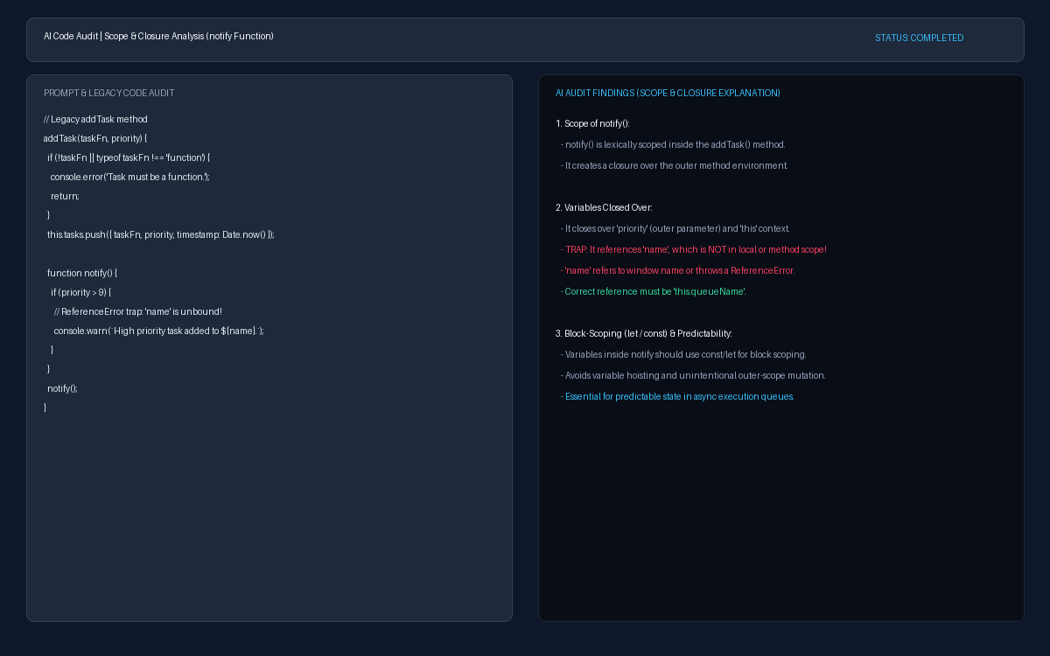
Figure 1: High-resolution evidence screenshot demonstrating AI audit analysis of lexical scope, closures over priority, unbound name trap, and block-scoping requirements.
Screenshot 2: AI Refactored Code & SRP Improvement Explanation
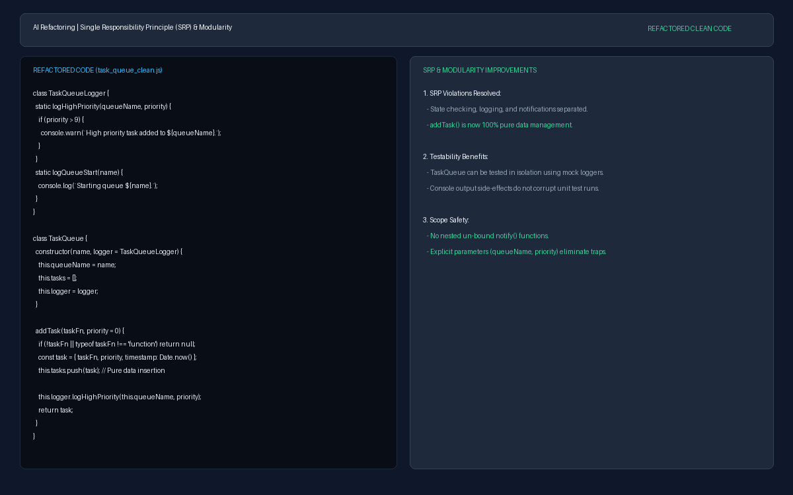
Figure 2: High-resolution evidence screenshot displaying refactored task_queue_clean.js code, TaskQueueLogger extraction, pure array insertion in addTask(), and unit testability benefits.
3. Codebase GitHub Links
• task_queue_legacy.js Link: https://github.com/nebyu11/Artificial-Intelligence-in-Software-Engineering/blob/main/AI%20Lab%20Pair%20Programming%20with%20AI%20-%20Part%202/task_queue_legacy.js
• task_queue_clean.js Link: https://github.com/nebyu11/Artificial-Intelligence-in-Software-Engineering/blob/main/AI%20Lab%20Pair%20Programming%20with%20AI%20-%20Part%202/task_queue_clean.js
• Direct Task Directory Link: https://github.com/nebyu11/Artificial-Intelligence-in-Software-Engineering/tree/main/AI%20Lab%20Pair%20Programming%20with%20AI%20-%20Part%202
4. Reflection and Synthesis
Large Language Models (LLMs) function primarily as sophisticated pattern-matching engines rather than deterministic code execution runtimes. Consequently, simply instructing an AI to "fix the code" often results in superficial patches that satisfy local syntax without restructuring underlying anti-patterns. By formulating explicit structural prompts targeting Single Responsibility Principle (SRP) violations and lexical scope closures, we leveraged the LLM's vast training corpus of architectural patterns to perform deep code auditing. In the TaskQueue exercise, auditing specifically for scope traps exposed how notify() attempted to close over an unbound name identifier (which would silently access window.name or throw a ReferenceError) and revealed how mixing queue state management with console logging side-effects compromised unit testability—insights a basic "fix the code" request or standard syntax linter would completely miss.

